1. Graphical user interface, text, application

   Description automatically generated

1. Text, letter

   Description automatically generated

1. 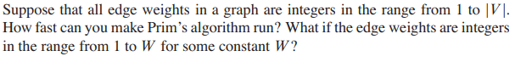

1. Text, letter

   Description automatically generated

1. Text, letter

   Description automatically generated

